Emergency Action Plan
This document can be used for sessions held at managed venues or venues where there are no staff. Where the coach is ultimately responsible for health and safety there is greater onus on them to ensure that safety provision is adequate. EAP should be read in conjunction with the Risk Assessment.

Venue: |  | ARDINGLY COLLEGE POOL
EAP created by: |  | Steve McMenamin |  | Date Created: | 06/01/2022
Venue Address:  (Inc. Postcode/ Grid Reference) |  | THE SWIMMING POOL  ARDINGLY COLLEGE  COLLEGE ROAD  ARDINGLY  RH17 6SQ
Type(s) of Activity this EAP applies to: |  | POOL BASED CLUB SWIM SESSIONS
Who is ultimately responsible for Health & Safety during these sessions: |  | ☒ Venue Staff  ☐ Coaching Staff  ☐ Other  Comments: | Lifeguard is initial point of contact and first responder
How will venue staff be contacted in emergency: |  | Lifeguard present poolside at all times
Location of Phone/Mobile Reception Tested: |  | Phone in pool office (9 for outside line). No mobile reception
Location of the nearest first-aid qualified person: |  | Lifeguard
Location of first-aid equipment: |  | Pool office
Location of Defibrillator: |  | Main college building
Non-Managed Venues
How to contact Emergency Services: |  | Lifeguard / Pool Supervisor
How will Emergency Services be directed to the scene of an incident: |  | Lifeguard/ Pool Supervisor
Who else is available to help in case of issues: |  | Venue staff
Managed Venues:
List the Actions that the COACH can undertake to ASSIST venue staff:
Non-Managed Venues:
List ALL the Actions that the COACH will undertake and Manage others to do if any of the following situations occurs:
Evacuation: | • Three blasts of a whistle by the Lifeguard signal a major incident  • Follow directions from Lifeguard or Pool Supervisor  • Direct people to clear the pool and assemble at the nearest Emergency Exit  • People should not go back to the changing rooms  • Instruct people not to run  • Be prepared for the Evacuation to be cancelled by Lifeguard or Pool Supervisor  • Lifeguard or Pool Supervisor will issue foil blankets  • Take a register to ensure all participants can be accounted for  • Leave the building on instruction from Lifeguard or Pool Supervisor  • Keep all participants together and remain with them Await further instruction from Lifeguard or Pool Supervisor  • Temporary shelter is available in the gym building at the foot of the slope  • Access code combination is C1806Z  • Readmittance can only be authorised by the Emergency Services first, and then the Lifeguard or Pool Supervisor
Missing Person: | • Alert Lifeguard or Pool Supervisor  • Assist staff in search of premises  • Contact participants emergency contact. Coaches should have these for each session but are also available from Head Coach, Club Chair, Club Membership Secretary
Minor Injury: | • Upon discovery of a casualty contact Lifeguard and pass casualty to them  • First aid to be administered by Lifeguard or Pool Supervisor (nominated First Aid provision for all sessions)  • Coach should consider the safety and welfare of the remaining participants and STOP the session if they are involved in treating the casualty  • The Coach should be present if the First Aider is a different gender from the casualty  • Lifeguard or Pool Supervisor to report matters to venue HSE and Compliance Manager  • The Coach should complete an Accident Report Form as soon as possible (within 24 hours) – make notes on the Session Plan in the interim  • The Coach should retain a copy for their records and pass a copy on to the Club Safety & Welfare Officer
Major Injury: | • Upon discovery of a person with MAJOR injuries inform the Lifeguard or Pool Supervisor  • STOP the session  • Three blasts of the whistle by Lifeguard signals evacuation of the water immediately  • The Lifeguard will use the pool alarm to summon additional venue support  SUPPORT THE LIFEGUARD / POOL SUPERVISOR – LIKELY ACTIONS REQUIRED:  • Send for Defibrilator (located in Main College Building)  • Ensure Emergency Services are called  • If the casualty is in the water, assist Lifeguard if required  • A participant may be sent to seek additional help from other parts of the venue and/or summon Emergency Services  • Anyone sent away from the pool MUST return  • Lifeguard or Pool Supervisor will take appropriate First Aid/Resuscitation action  • Instruct all swimmers to leave the pool, move the group away from the casualty  • If appropriate, nominate an Assistant Coach or other Club Member to manage the group  • Pass emergency contact details to Emergency Services – coaches should have these for each session but are also available from Head Coach, Club Chair, Club Membership Secretary  • After the emergency services have dealt with the situation The Coach should complete an Accident Report Form as soon as possible (within 24 hours) – make notes on the Session Plan in the interim  • The Coach should retain a copy for their records and pass a copy on to the Club Safety & Welfare Officer

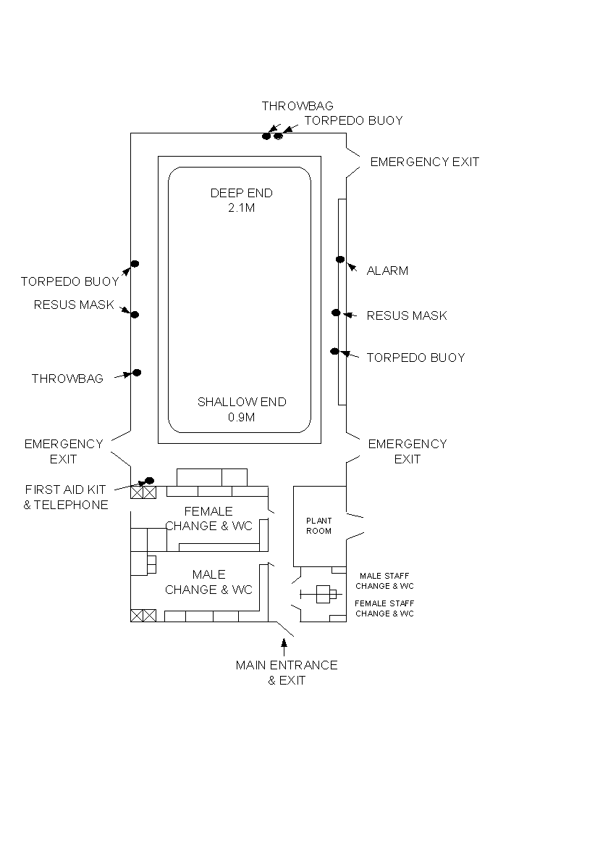
Insert Diagram(s) of layout of venue with key safety elements marked (this page is intended to be shared between Risk Assessment and EAP):

