Risk Assessment Form
This form should be completed with a list of hazards that affect the session, and should be written from a coaching perspective, not a venue management perspective. For each risk assessment there should be associated Emergency Action plan to be used in case a risk occurs.
Venue: |  | CLAIR PARK | Venue Contact Name & Contact Details: | START & FINISH POINT:  DOLPHIN LEISURE CENTRE  PASTURE HILL ROAD  HAYWARDS HEATH  RH16 1LY
Address:  (Include postcode) |  | THE RUN VENUE IS AT:  CLAIR PARK  PERRYMOUNT ROAD  HAYWARDS HEATH  WEST SUSSEX  RH16 3DN
Group: |  | MID SUSSEX TRIATHLON CLUB | Location of first-aider: | DOLPHIN LEISURE CENTRE  (MEETING POINT FOR RUN)
Date: |  | THURSDAY EVENINGS | Location of Defibrillator | RECEPTION - DOLPHIN LEISURE CENTRE (MEETING POINT FOR RUN)
Time: |  | 7.30PM – 8.30PM | Location of telephone: | • COACH HAS MOBILE  • CLAIR HALL (ADJACENT TO PARK)  • DOLPHIN LEISURE CENTRE
Participants: | Number: | 5-12 | Location of toilets: | DOLPHIN LEISURE CENTRE  (MEETING POINT FOR RUN)
 | Age: | ADULTS (18-65) | Location of changing  rooms: | DOLPHIN LEISURE CENTRE  (MEETING POINT FOR RUN)
 | Ability: | MIXED – FROM NOVICE TRIATHLETES TO EXPERIENCED TRIATHLETES | Location of first-aid kit: | RECEPTION - DOLPHIN LEISURE CENTRE (MEETING POINT FOR RUN)
Lead coach name: |  | NEIL GILES – 07725 656950 | Stocked and maintained: | Yes No
Venue documents read and understood  (please ✔ appropriate box): |  | Normal operating procedures:  Yes No | Additional notes: | The session will take place in a public park and is therefore not a managed venue and has no facilities of its own.
Health and safety policy:
Yes No
Emergency action plan (EAP):
Yes No

Name of person conducting risk assessment: | Signed: | Date:
Steve McMenamin |  | 02/02/2022

Risk Assessment Form
Location &  Description of  Hazard: | People  at Risk: | Level of Risk (High/Medium /Low): | Advice  Required:  (from whom) | Action(s) to Mitigate/  Remove Risk: | Person  responsible  for resolution: | Residual Risk: After resolution | Dates  Reviewed
LONE RUNNING | RUNNERS | Likelihood:  MEDIUM  Impact:  LOW | X No  Yes  If yes, who: | • All athletes to be in sight of Coach at all times  • Athletes briefed to run with similar abilities  • New runners to be have a nominated buddy  • Group advised to keep to designated route as briefed • All participants recommended to carry mobile phone | LEAD COACH | Likelihood:  LOW  Impact:  LOW | 02/02/2022
GETTING LOST | RUNNERS | Likelihood:  LOW  Impact:  LOW | X No  Yes  If yes, who: | • All athletes to be in sight of Coach at all times  • Athletes briefed to run with similar abilities  • New runners to be have a nominated buddy  • Group advised to keep to designated route as briefed • Re-group location identified in session briefing  • All participants recommended to carry mobile phone | LEAD COACH | Likelihood:  LOW  Impact:  LOW | 02/02/2022
SLIPS, TRIPS AND FALLS | RUNNERS | Likelihood:  LOW  Impact:  MEDIUM | X No  Yes  If yes, who: | • Group advised of risks in briefing  • All participants recommended to carry mobile phone | LEAD COACH | Likelihood:  LOW  Impact:  MEDIUM | 02/02/2022
BROKEN PATH DUE TO TREE ROUTE GROWTH | RUNNERS | Likelihood:  MEDIUM  Impact:  MEDIUM | X No  Yes  If yes, who: | • Group advised of the  condition of the path as part of briefing  • Specific areas or concern pointed out  • Use cones to make  particularly bad areas visible | LEAD COACH | Likelihood:  LOW  Impact:  LOW | 02/02/2022

Location &  Description of  Hazard: | People  at Risk: | Level of Risk (High/Medium /Low): | Advice  Required:  (from whom) | Action(s) to Mitigate/  Remove Risk: | Person  responsible  for resolution: | Residual Risk: After resolution | Dates  Reviewed
CROSSING ROADS | RUNNERS  / COACH | Likelihood:  LOW  Impact:  HIGH | X No  Yes  If yes, who: | • Use traffic aids (safe crossing points) at all times  • Slow, stop and walk across roads  • Group to wear hi-vis clothing (mandatory) | LEAD COACH | Likelihood:  LOW  Impact:  MEDIUM | 02/02/2022
OTHER ROAD  USERS – VEHICLES & BICYCLES | RUNNERS  / COACH | Likelihood:  LOW  Impact:  HIGH | X No  Yes  If yes, who: | • Use traffic aids (safe crossing points) at all times  • Slow, Stop and walk across roads  • Group to wear hi-vis clothing (mandatory) | LEAD COACH | Likelihood:  LOW  Impact:  HIGH | 02/02/2022
POOR WEATHER | RUNNERS  / COACH / | Likelihood:  MEDIUM  Impact:  HIGH | X No  Yes  If yes, who: | • Weather forecast taken into account prior to session  • Cancel session if high winds or icy conditions are forecast | LEAD COACH | Likelihood:  LOW  Impact:  HIGH | 02/02/2022
POOR LIGHT  LEVELS | RUNNERS  / COACH / OTHER  PARK  USERS | Likelihood:  MEDIUM  Impact:  MEDIUM | X No  Yes  If yes, who: | • Group made aware of light levels as part of briefing  • Run course to use the best-lit areas only  • Group to remain in sight of coach at all times | LEAD COACH | Likelihood:  MEDIUM  Impact:  LOW | 02/02/202202/02/2022
OTHER PARK  USERS – DOG  WALKERS,  RUNNERS,  GENERAL PUBLIC, CYCLISTS,  CHILDREN PLAYING | RUNNERS  / COACH / OTHER  PARK  USERS | Likelihood:  HIGH  Impact:  LOW | X No  Yes  If yes, who: | • Group made aware of other park users in briefing  • Respect other park users and keep to one side of the path • Use the grass verge when required  • Lead runners to alert others | LEAD COACH | Likelihood:  HIGH  Impact:  LOW
 |  | Likelihood:  Impact: | No  Yes  If yes, who: |  |  | Likelihood:  Impact:

Location &  Description of  Hazard: | People  at Risk: | Level of Risk (High/Medium /Low): | Advice  Required:  (from whom) | Action(s) to Mitigate/  Remove Risk: | Person  responsible  for resolution: | Residual Risk: After resolution | Dates  Reviewed
 |  | Likelihood:  Impact: | No  Yes  If yes, who: |  |  | Likelihood:  Impact:
 |  | Likelihood:  Impact: | No  Yes  If yes, who: |  |  | Likelihood:  Impact:

Add more pages as required
Insert Diagram(s) of layout of venue with key safety elements marked (this page is intended to be shared between Risk Assessment and EAP):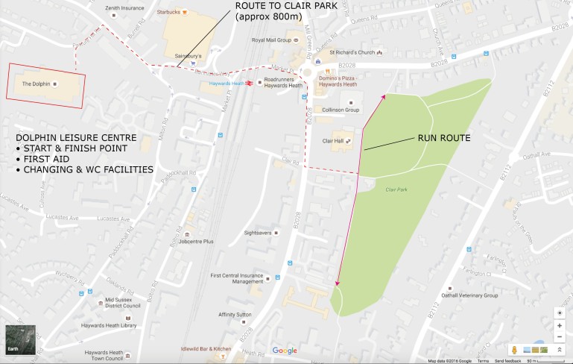
THE DOLPHIN LEISURE CENTRE
